|  |
| --- |
| Rijksdienst voor Ondernemend Nederland |
| Online Filing |
| User Manual Guide |

|  |
| --- |
| Version 0.7 |

Table of Contents

1. Introduction 2

2. Online Filing dashboard 3

2.1 Top of the page: left side 5

2.2 Top of the Page: right side 5

3.2.1 User Management 7

3.2.2 My profile 8

3.2.3 My organization 9

3.2.4 Managing roles of the users. 10

3.2.5 Switch account 11

2.3 Dashboard 12

2.3.1 National patent submissions: Create submission 12

2.3.2 National patent submissions: Create subsequent action 22

2.4 My submissions 29

2.4.1 National patent submissions 30

3.4.1.1 Sign submission 32

2.4.2 National patent submissions: Subsequent Action 33

2.4.3 EP validation submissions 34

2.4.4 EP validation submissions: Subsequent Action 35

# Introduction

This Manual User Guide of the Online Filing describes the various functionalities of the web-based application and how to make best use of it by showing how to navigate the application, process a submission and manage users.

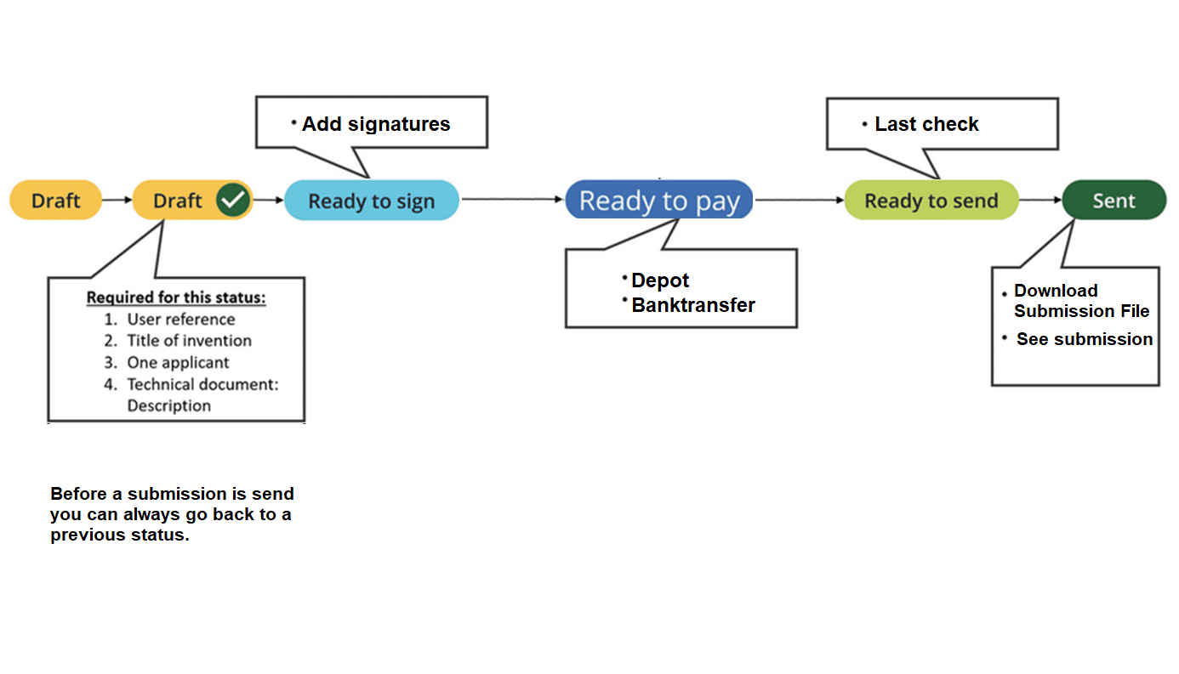You can have a look at the Functional training of the Online Filing application done by EPO covering essential topics such as navigation, processing a submission and managing users in the following link: [Online Filing Functional Training - Overview | Rise 360 (articulate.com)](https://rise.articulate.com/share/XJb6YV_SEQpeKfk4pwNgy84DrDKilTog#/).

Figure 1: An overview of the flow in Online Filing

# Online Filing dashboard

After signing in, you are now in the Online Filing dashboard. This is the graphical user interface which provides the user with an overview of all submissions relevant to their user profile or organization.

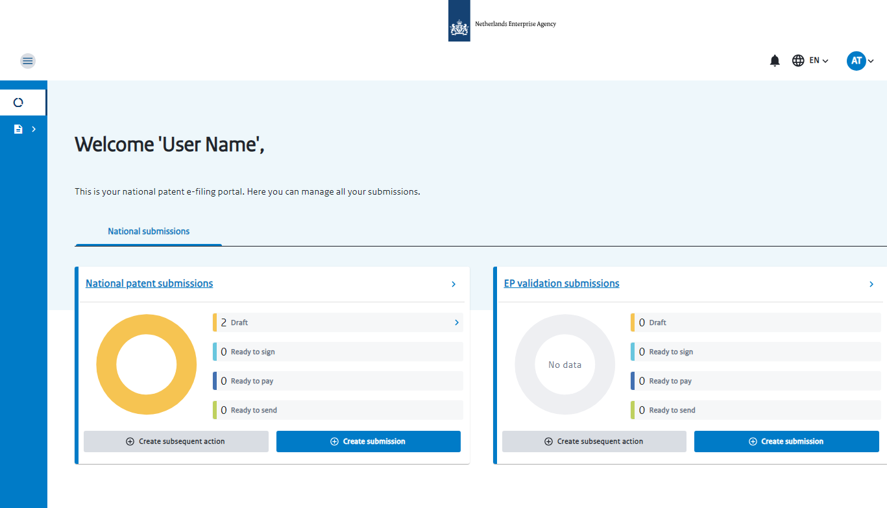

Figure 2 - Main page of the Online Filing dashboard

To better explain all the functionalities of the Online Filing dashboard, let’s divide the page in three sections: **1)** Top of the page: left side, **2)** Top of the page: right side and **3)** Dashboard, as you can see in Figure 3.

Top of the page: right side

The functionalities of the three sections will be explained in the next chapters.

Dashboard



Top of the page: left side

Figure 3 - Three main sections of the Online Filing dashboard page.

By clicking in the Netherlands Enterprise Agency logo, the User can return to the main Online Filing dashboard page.

## Top of the page: left side

On the **left side of the top of the page**, you can find the Menu option.

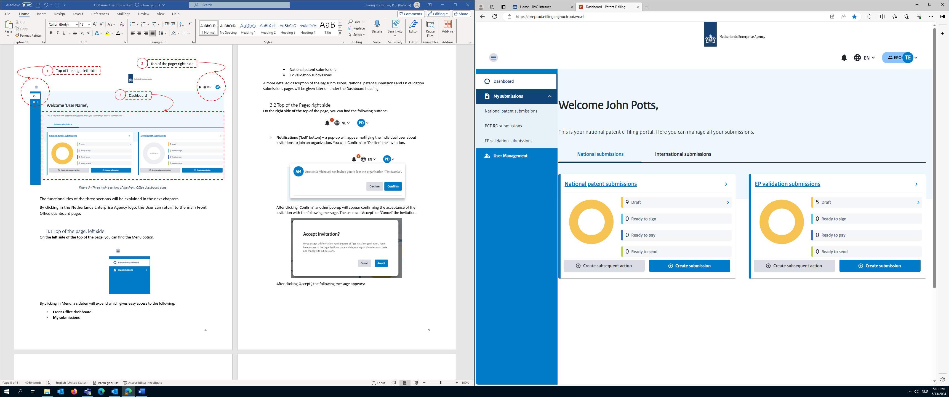

Figure 4 - Menu

By clicking in Menu, a sidebar will expand which gives easy access to the following:

* **Dashboard –** it directs you to the Dashboard page.
* **My submissions**
  + National patent submissions – on this page you can create and manage national patent applications.
  + EP validation submissions – on this page you can create and manage EP validation submission drafts.
* **User Management** – it directs you to the My organization page where you can manage your organization. This is not available if you are logging into your personal individual account.

A more detailed description of the My submissions, National patent submissions and EP validation submissions pages will be given later on under the Dashboard heading.

## Top of the Page: right side

On the **right side of the top of the page**, you can find the following buttons:

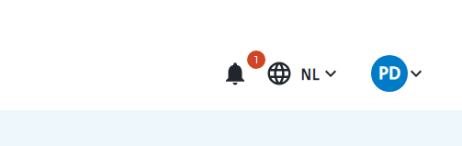

Figure 5 - Notifications, Language and User management buttons

* **Notifications** (‘bell’ button) – a pop-up will appear notifying the individual user about invitations to join an organization. You can ‘Confirm’ or ‘Decline’ the invitation.

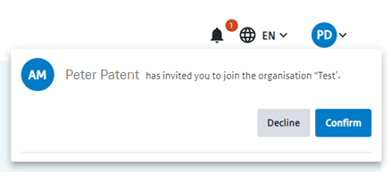

Figure 6 - Pop-up to join Organization

After clicking ‘Confirm’, another pop-up will appear confirming the acceptance of the invitation with the following message. The user can ‘Accept’ or ‘Cancel’ the invitation.

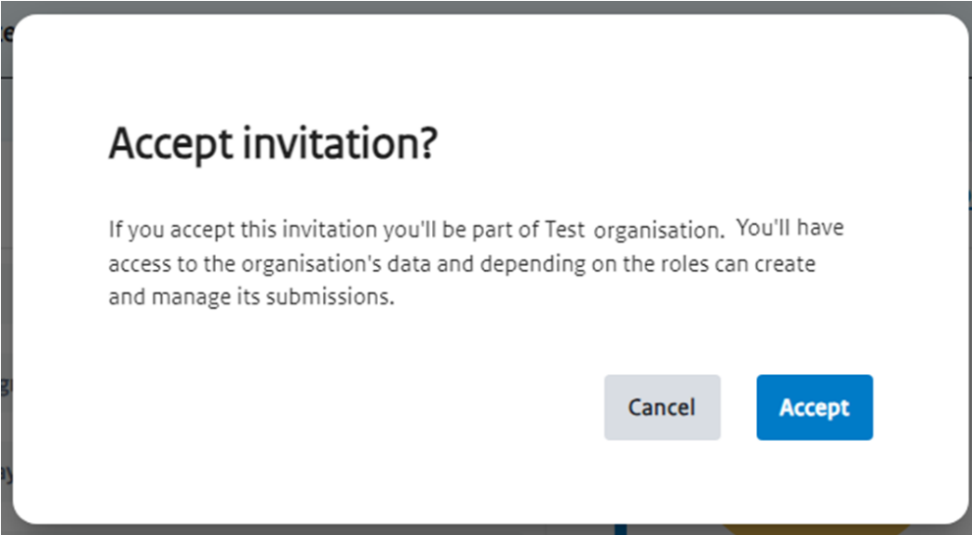

Figure 7 - Pop-up to accept invitation of joining Organization

After clicking ‘Accept’, the following message appears:

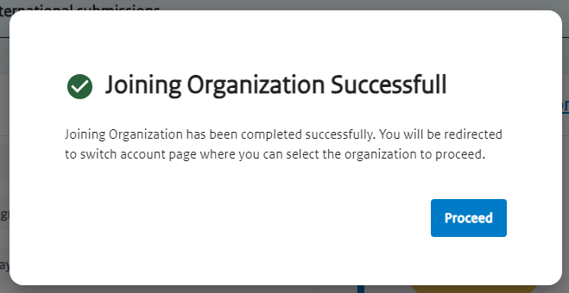

Figure 8 - Pop-up confirming that the user has joined the Organization successfully

* **Language** – click here to change to a different available language for the Online Filing: Nederlands (NL) or English (EN).
* **User profile** – click here to display the user profile that is signed in. By clicking here you can access more information about your profile, your roles, switch to an organization, create an organization and sign out. More information is detailed in the User Management chapter.

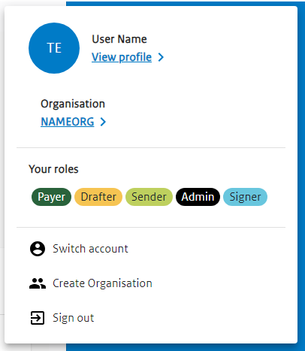

Figure 9 – ‘User management’

### 3.2.1 User Management

By clicking in the User Profile button you can access the following information:

Table 1 – ‘User management’ functionalities

|  |  |
| --- | --- |
| View profile | It directs you to the ‘My profile’ page, where you can edit and view all the details regarding your personal profile. |
| Type of profile | It shows which type of user profile you are signed in:   * Individual * Organization   By clicking here, it will direct you to the ‘My organization’ page. |
| Your roles | The user can have one to five roles:   * Signer * Drafter * Admin * Payer * Sender   The roles correspond to which part of the process the user can complete. |
| Switch account | You can switch between Individual and Organization accounts (if that applies to the User) |
| Create Organization | An individual user can create an organization. |
| Sign out | You sign out of the interface. |

### 3.2.2 My profile

In the ‘’My profile’ page, you can view and edit all the details regarding your personal profile, which is divided in three main sections: My details, Organization and Manage Account.

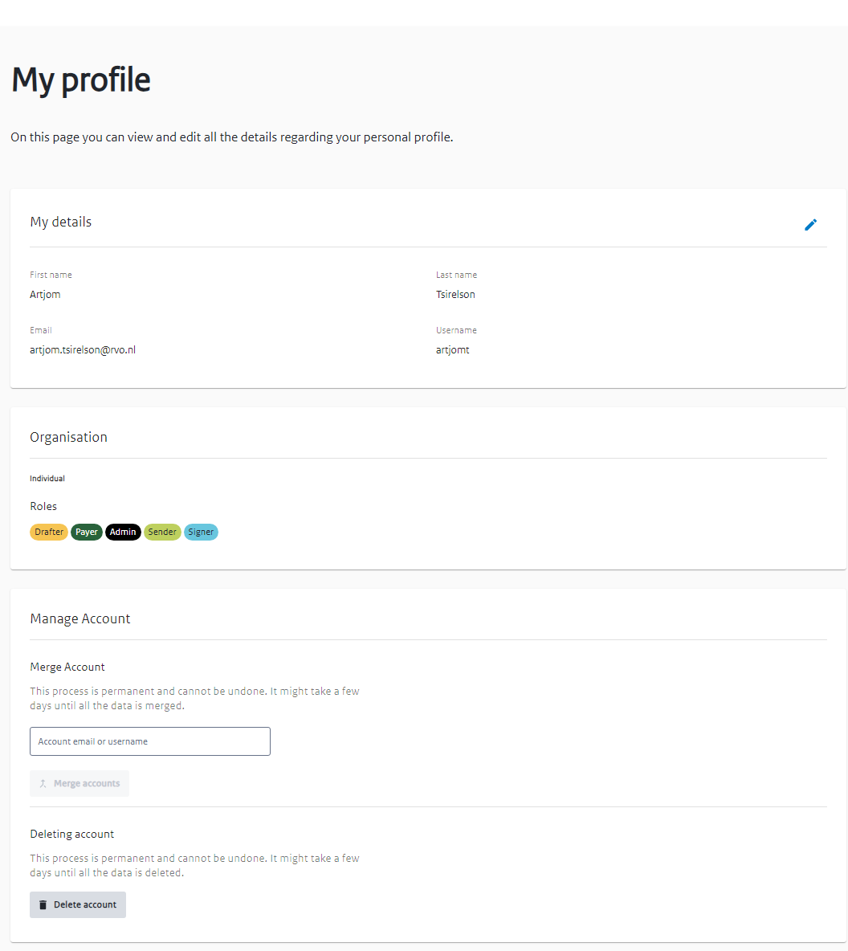



Figure 10 - ‘My profile’ page

Table 2 – ‘My profile’ page functionalities

|  |
| --- |
| My details |
| You can see the following personal information:   * First name * Last name   You can edit the following fields:   * Email * Username * Initials |
| Organization |
| You can see the Individual(s) in your Organization and their respective(s) roles (Drafter, payer, Admin, Sender and/or Signer). |
| Manage Account |
| * Merge Account   You can merge accounts by submitting the email or username of the account you want to merge with.   * Delete Account   You can delete the user account.  Both processes are permanent and cannot be undone. It might take a few days until all the data is merged or deleted. |

### 3.2.3 My organization

In this page, you can view, add, edit and remove the individual(s) belonging to your organization.

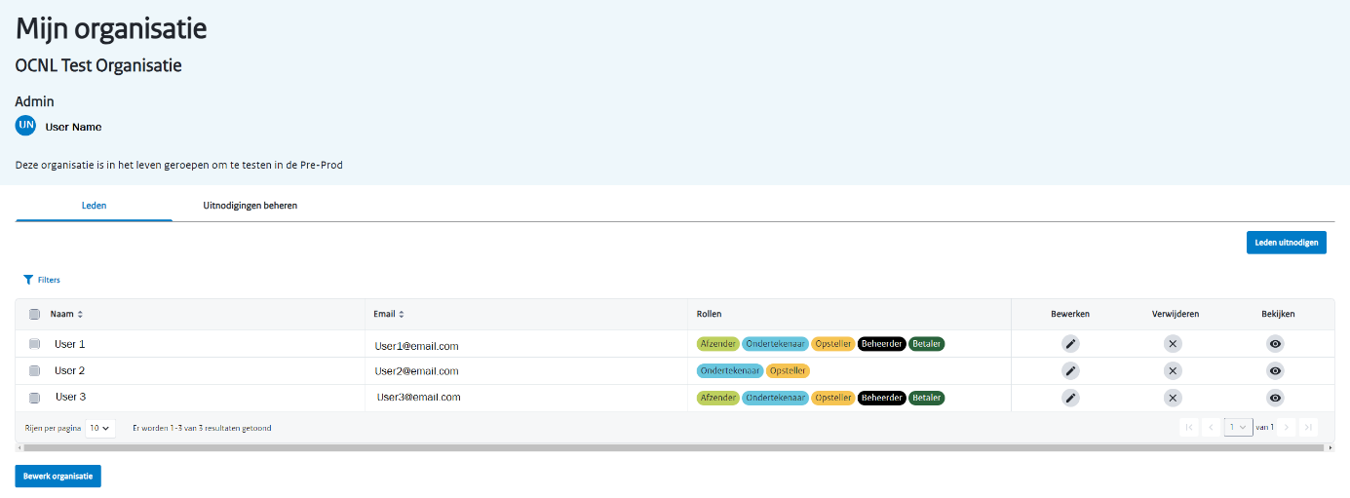

Figure 11 –‘ My Organization’ page

Table 3 – ‘My organization’ page functionalities

|  |  |
| --- | --- |
| Invite Members | You can invite other Individual Users to be part of your Organization after you have created an Organization. |
| Filters | You can filter the individuals by   * Name * Email   and/or   * Roles (Drafter, Signer, Sender, Payer, Admin) – you can search more than one role at the same time and the results will show all the individuals having one role and/or the other   By clicking ‘enter’ the filter will be assigned. You can click in Clear filters if you wish to delete all filters applied or you can click on the ‘x’ next to each filter to delete it. |
| ‘Select all’ square  (next to ‘Name’) | Selects all individuals from the table |
| ‘Select’ individual square | Selects the respective individual.  You can select more than one individual this way.  An additional ‘Remove’ button appears next to ‘Invite Members’. |
| Edit | If have the Admin role:  You can **edit** the Organization in the ‘My profile’:   * **Add or Remove Roles** from an Individual user * **Remove an Individual user** from the organization (removing a user from your organization will make the user lose access to all the information linked to the organization)   A pop-up window will appear to remove the user or cancel the action. The user removed will stop having access to all the submissions of the organization. |
| Remove | A pop-up window will appear to **remove** the user or **cancel** the action. The user removed will stop having access to all the submissions of the organization. |
| View | You are directed to the ‘’My profile’. You can view ‘My details’ and ‘Organization’. You edit ‘Organization’. |
| Results shown | You can filter the number of rows of individual users shown by page (10, 15, 20, 25, 50 or 100 rows). You can click in the arrows to go to the next page of results. |
| Edit Organization | After you have created an Organization you can edit the Organization. |

### 3.2.4 Managing roles of the users.

You change the roles of user in the my organization page by pressing the edit button next to the user you want to change.

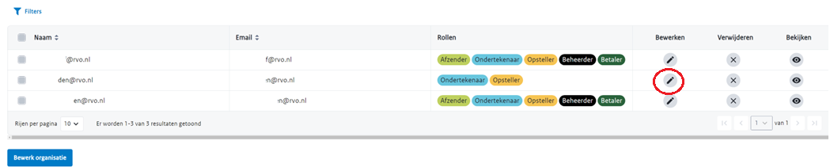

Next you need to press the edit button at the top right. You can then select the roles this user should have.

### 3.2.5 Switch account

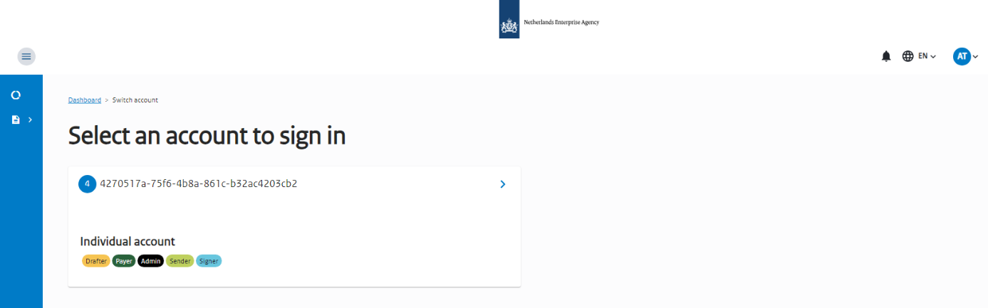By clicking in Switch Account, you are directed to ‘Select an account to sign in’ page where you can select switch between your Individual account and the Organization account associated to your profile. A user can only have one Individual account but can have to a maximum of 10 organization accounts.

Figure 12 – ‘Change accounts’ page

## Dashboard

The Dashboard gives you an overview of all current National submissions created by the user in terms of overview cards: **National patent submissions** and **EP validation submissions**. The following actions can be done:

1. **Create submission** – click here to create a submission.
2. **Create subsequent action –** click here to submit a subsequent action regarding a submission. A pop-up window will appear to start a new subsequent action.

Figure 13 - Dashboard page: National patent and EP validation submissions



The overview cards give you a snapshot of all current submissions created by the user and their relevant states such as Draft, Ready to sign, Ready to pay, Ready to send, etc. (more information on the status of the submissions can be found in the My submissions chapter). Already send submissions are not shown here.

* + 1. National patent submissions: Create submission

When clicking on ‘Create submission’, the user is directed to the ‘Patent online filing’ page. Here you can fill in the information necessary for the national patent granting procedure. All fields are required unless specified otherwise.

The information needed is divided into the following steps:

* Basic filing info
* Parties
* Declarations
* SEQL & Bio information
* Attachments
* Payment of fees

At the end of the page there is a Summary comprising an overview of all the information.

There is a side bar on the right side of the page that indicates what are the minimum requirements for the required information (Basic filing info, Parties, Attachments, Payment of fees) as you hover each of the steps. As the required fields in each step are completed a green arrow is shown marking such step as ‘Completed’, as seen below. Furthermore, if you click on each field (Basic filing info, Parties, Declarations, SEQL & Bio information, Attachments, Payment of fees, Summary), it will automatically take you to the exact location of the field on the page.

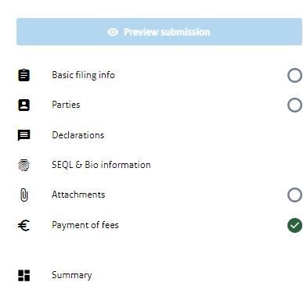

Figure 14 - Side bar of the ‘Patent online filing’ page

Table 4 - Minimum required fields for each step in the ‘Patent online filing’ page

|  |  |
| --- | --- |
| Minimum required fields in each step | |
| Basic filing info | User Reference |
| Parties | At least one confirmed applicant |
| Attachments | An attachment of type of description |
| Payments of fees | Select at least a payment intention |

Only when the User Reference field in Basic filing info is filled in is it possible to complete the other required steps – Parties, Declarations, SEQL & Bio information, Attachments and Payments of fees. A green arrow will appear next to each information when all necessary fields are completed.

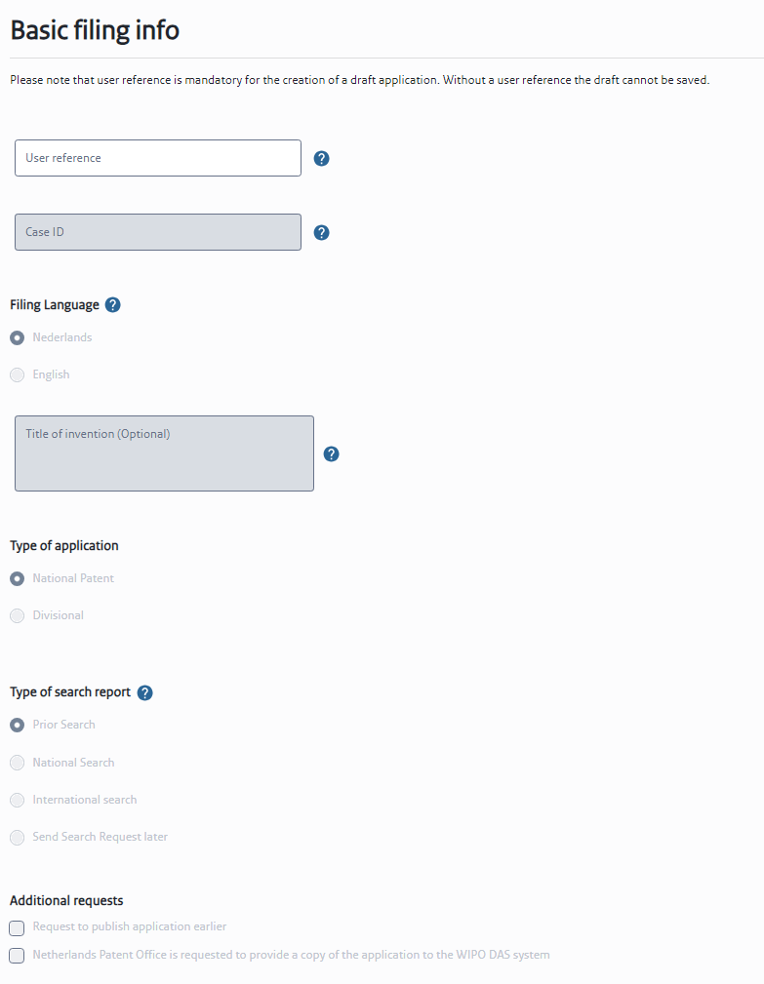

Figure 15 – ‘Basic info’ section

Table 5 – ‘Basic info’ section of the 'Patent online filing' page

|  |  |
| --- | --- |
| Basic filing info | |
| User reference | Enter a user reference that includes alphanumeric characters. The user reference is mandatory for the creation of a draft application. Without a user reference the draft cannot be saved. |
| Case ID | A unique identifier is automatically generated by the system for each submission to help ensure that a submission can be easily tracked and identified. |
| Filing Language | Select the submission language:   * Nederlands * English |
| Title of invention (optional) | Enter the title of invention  (A title of invention must be submitted, but can be done at a later stage, Art. 24 ROW 1995) |
| Type of application | Select the type of application:   * National Patent * Divisional   If you select ‘Divisional’, two fields will appear to be completed:   * Divisional application number * Divisional Filing Date |
| Type of search report | Select the type of search report:   * Prior Search * National Search * International Search * Send Search Request later   A request for search needs to be filed within 13 months calculated from the first filing date. If you request for a prior search, please submit within 13 months from the first filing date a search report performed by the European Patent Office or the Netherlands Patent Office (see Art. 6 lid 5 Uitvoeringsbepalingen). |
| Additional requests | You can select up until two additional requests:   * Request to publish application earlier. * Netherlands Patent Office is requested to provide a copy of the application to the WIPO DAS system.   When selecting this request, a required field to fill in the DAS email will appear. |

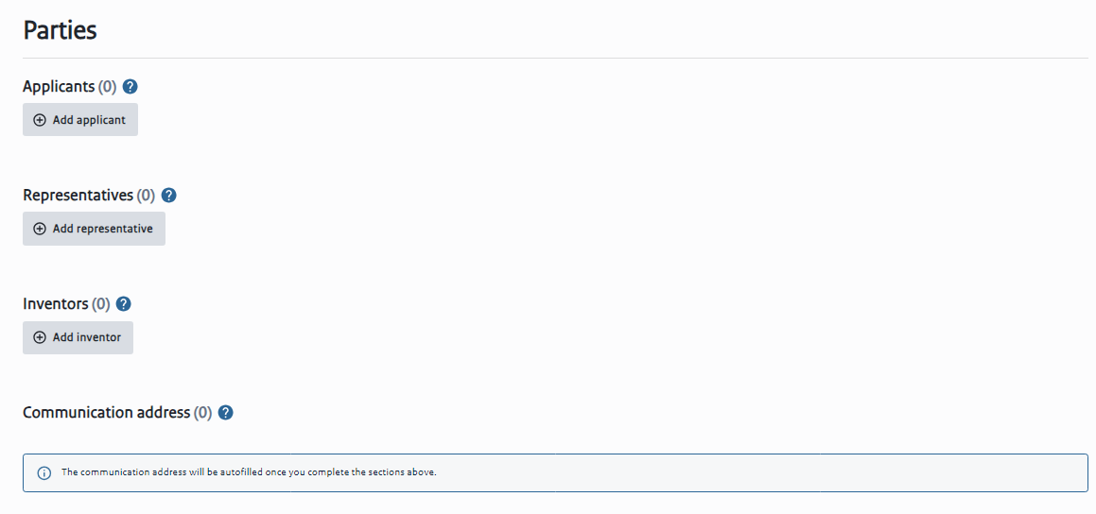

Figure 16 – ‘Parties' section

Table 6 – ‘Parties' section of the 'Patent online filing' page

|  |
| --- |
| Parties |
| Applicants - One or more applicants can be added and in any combination of legal and natural.  Representative - Only one representative can be added.  Inventors - One or more inventors can be added. Inventor details are mandatory, but can be filled in later (Art. 24 ROW 1995).  Add applicant/representative/inventor – a pop-up will appear informing that the communication address will be updated with data from the party (in case there is no communication address yet). When you click ‘Yes, I’m sure’ the fields bellow will appear to be completed.  The Communication address will be the address of the representative by default. If there is no representative, the communication address will be of the first Applicant (an address from a European Economic Area country is mandatory).  If you select type of applicant - Legal entity, the following fields will appear:    Figure 17 - Fields to fill in when the applicant is a Legal entity  If you select type of applicant – Natural person, the following fields will appear:    Figure 18 - Fields to fill in when the applicant is a Natural person  The following fields are required to confirm the party: First names, Last name, Company name, Street Address or P.O. box, postal code, city and Country. The identification number is optional, but in case it is known, please add here the identification number issued by the Netherlands Patent Office.  If you select ‘ The Applicant is also an inventor’, the following option can also be selected ‘Waiver of right to be mentioned as inventor’.  It is possible to see the Parties in Grid view or List view. By clicking in the three dots next to the Grid or List you can Edit or Delete a party. |

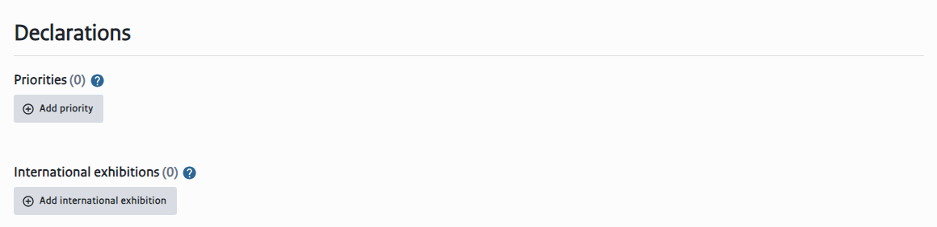

Figure 19 – ‘Declarations' section

Table 7 – ‘Declarations' section of the 'Patent online filing' page

|  |  |
| --- | --- |
| Declarations  Once you have added a declarations; It is possible to see the Declarations in Grid view or List view. By clicking in the three dots next to the Grid or List you can Edit or Delete the declaration. | |
| Priorities | One or more priorities can be added. The application number must be provided within 16 months of the first submissions. The date of filing of the application and the date of filing of the priority may differ by a maximum of a year.  **New declaration of priority information**  The following fields are required: type of office, office, kind of application, application number, filing date.  The option “Request for retrieval of priority document from DAS” can be selected and a field for the DAS code will appear to be completed. |
| International exhibitions | One or two international exhibitions can be added.  **New declaration of priority information**  The following fields are required: International exhibition, City (filled automatically), exhibition date. |

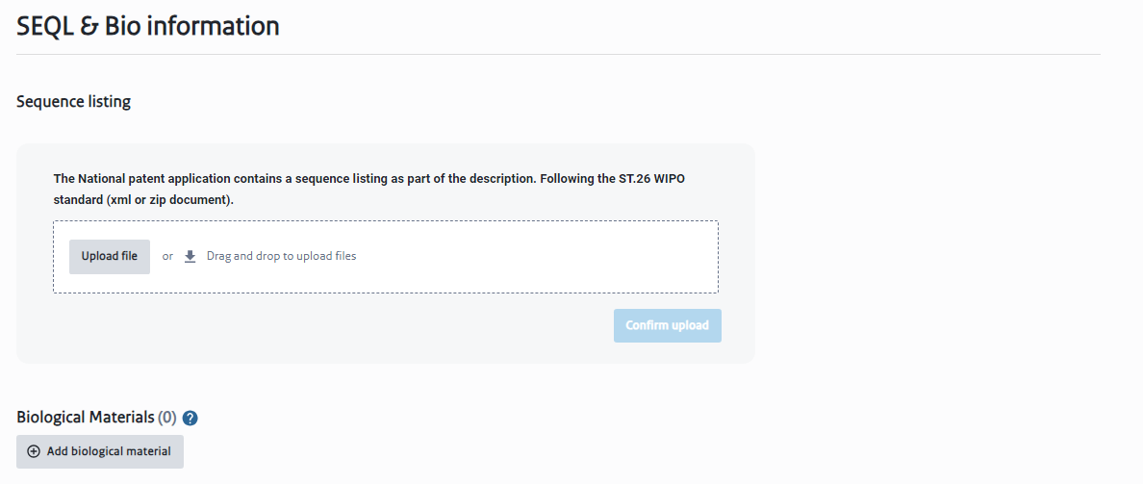

Figure 20 – ‘SEQL & Bio information’ section

Table 8 – ‘SEQL & Bio information’ section of the 'Patent online filing' page

|  |  |
| --- | --- |
| SEQL & Bio information | |
| Sequence listing | If the National patent application contains a sequence listing as part of the description you can add it here, following the ST.26 WIPO standard (xml or zip document). |
| Biological Materials | Biological information can be added if the invention relates to and/or uses biological material.  **Biological material**  The following fields are required: Country of depositary institution, depositary institution, accession number, date of deposit.  There is the option of selecting ‘Availability restricted to expert’.  You can upload the biological material documents in the formats (PDF, JPEG, JPG, PNG, DOC, DOCX).  Type of biological material document:   * Viability Statement * Permission to provide microorganism sample * Notification of receipt |

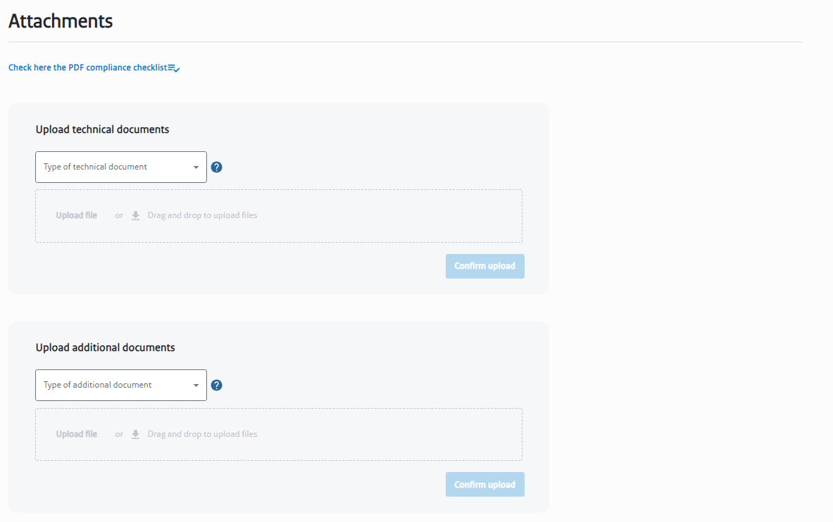

Figure 21 – ‘Attachments' section

Table 9 – ‘Attachments' section of the 'Patent online filing' page

|  |  |
| --- | --- |
| Attachments | |
| Click here the PDF compliance checklist | To guarantee compliance, a checklist can be checked here to ensure that your PDF generator and resulting PDFs meet the criteria. |
| Upload technical documents | At least a description attachment must be added. Other attachments can be filed later on. It is also possible to upload a combined file which includes different types of attachments. It is a requirements to specify the number of pages of each item. |
| Upload additional documents | You can upload additional documents. This saves time by not having to send them using subsequent actions. |

The fees to be paid will automatically appear in the Payment of fees section based on the information given above. The fees information will appear in terms of its corresponding code, description, amount, quantity and subtotal to be paid.

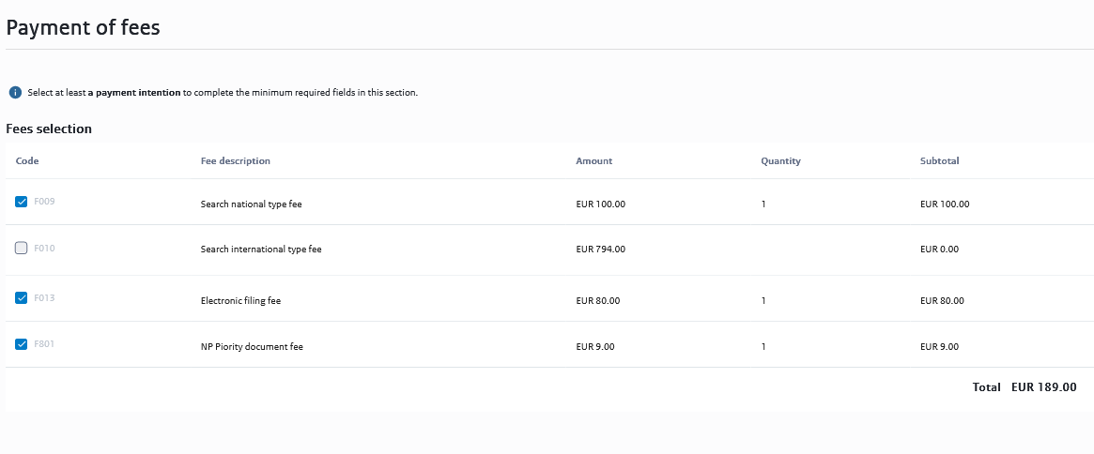

Figure 22 – ‘Payment of fees' section

The Summary section at the end of the page gives you an overview of the most important information of each section. You can edit such information by clicking in the ‘pencil’ button and you will be directed to the specific field above. This is the last chance to verify the data before finishing the draft.

At the end of the page you can Save or Save & Close your draft.

The last step to complete the draft is to select the ‘Send to sign’ button at the end of the page. A pop-up window will appear to confirm the status change from “Draft’ to ‘Ready to sign’ by selecting the Confirm button.

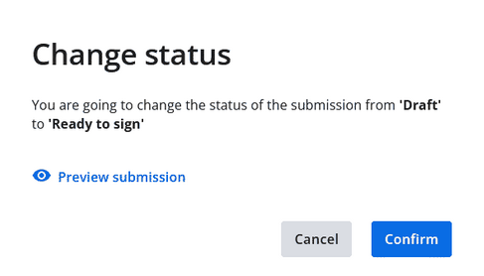

Figure 23 - Pop-up of ‘Change status’ of the submission

* + 1. National patent submissions: Create subsequent action

A pop-up window will appear to start a new subsequent action with the following required fields:

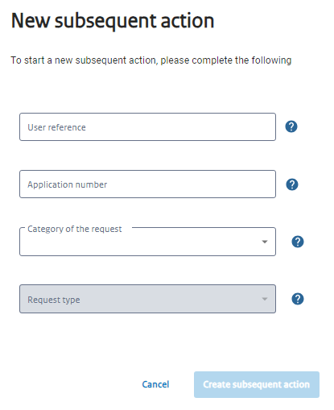

Figure 24 - Pop-up of ’New subsequent action’

Table 10 - 'New subsequent action' fields

|  |  |
| --- | --- |
| User reference | Enter a user reference that includes alphanumeric characters |
| Application number | Enter an existing application number (alphanumeric up to 7 characters) |
| Category of the request | You can select the category of the request from a list:   * Search request * Amended documents * Withdrawal * Other * Priority documents * Formal defects * Request for advice * Request for change of inventor * Appeal * Request restoration * Hearing * Sequence list (ST.26 XML) * Sequence list (ST.26 ZIP)   The category of the request represents a grouping of SA requests that have a common structure |
| Request type | Once the Category of the Request is filled in, you can select the type of request. The request type defines the type of Subsequent Action filed within the current form. |

While drafting the submission of each Subsequent Action, the user will be able to upload an attachment (see table below) and write some notes in the ‘Notes’ section. A summary is provided at the end of the page with an overview of the information related to the Subsequent Action.

Table 11 - Type of attachment for each request type in subsequent actions of National patent submissions

|  |  |  |
| --- | --- | --- |
| **Category of the request** | **Request type** | **Type of attachment** |
| Search request | Request prior search (6.5) | Accompanying letter |
| Request prior search |
| Search report |
| Request national search | Accompanying letter |
| Request national search |
| Request for urgent search |
| Request international search | Accompanying letter |
| Request international search |
| Request for urgent search |
| Amended documents | Amended documents | Removing feasibilities search report (Art. 35) |
| Accompanying letter |
| Modified description |
| Modified claims |
| Modified drawings |
| Modified abstract |
| Renunciation term modified documents |
| Request extension time limit modified documents |
| Request early publication |
| Withdrawal | Withdrawal | Withdrawal application |
| Withdrawal search request |
| Withdrawal priority |
| Accompanying letter withdrawal |
| Withdrawal request |
| Other | Other documents | Accompanying letter original documents |
| Accompanying letter power of attorney |
| Agent details |
| Power of attorney |
| Annulment of power of attorney |
| Other documents |
| Change of address |
| Letter agent |
| Request reimbursement |
| Request early publication |
| Priority documents | Priority documents | Accompanying letter |
| Claim priority |
| Translated priority document |
| Transfer of rights |
| Formal defects | Remove formal defects | Additional documents change of inventor details |
| Accompanying letter inventor details |
| Accompanying letter |
| Description |
| Claims English |
| Claims |
| Abstract |
| Figure abstract |
| Drawings |
| Remove formal defects with payment | Additional documents change of inventor details |
| Accompanying letter inventor details |
| Accompanying letter |
| Description |
| Claims English |
| Claims |
| Abstract |
| Figure abstract |
| Drawings |
| Request for advice | Request for advice | Withdrawal request |
| Reaction patent holder |
| Additional documents advice |
| Letter patent holder |
| Accompanying letter additional documents advice |
| Request for advice with payment | Additional documents advice |
| Advice request |
| Accompanying letter additional documents advice | |
| Request for change of inventor | Request for change of inventor details | Request for change of inventor details | |
| Appeal | Appeal procedure | Withdrawal request | |
| Accompanying letter of notice of appeal | |
| Notice of appeal | |
| Additional documents appeal | |
| Renunciation of appeal | |
| Request restoration | Request restoration | Withdrawal request | |
| Accompanying letter request restoration | |
| Additional documents request restoration | |
| Request restoration with payment | Accompanying letter request restoration | |
| Additional documents request restoration | |
| Request restoration | |
| Hearing | Hearing | Request postponement hearing | |
| Post after hearing | |
| Cancellation Hearing | |
| Additional documents hearing | |
| Sequence list (ST.26 XML) | Sequence list WIPO ST.26 XML format (XML) | Sequence list WIPO ST.26 format XML | |
| Sequence list (ST.26 ZIP) | Sequence list WIPO ST.26 ZIP format (ZIP) | Sequence list WIPO ST.26 format ZIP | |

By clicking Save & Close, the user is directed to the Subsequent Actions in the National patents submissions page (see below).

* + 1. EP validation submissions: Create submission

A pop-up window will appear to start a new EP validation with the following required fields:

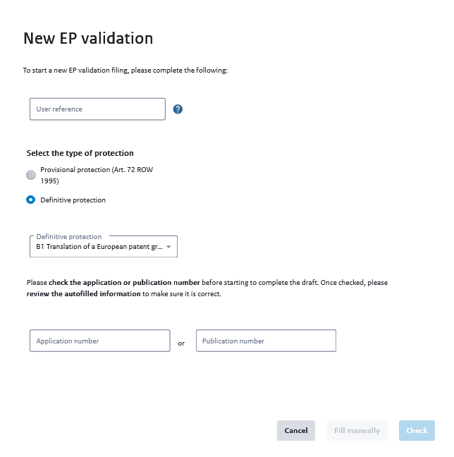

Figure 25 - Pop-up of ‘New EP validation’ in Create submission for EP validation submissions

Table 12 – ‘New EP validation’ fields

|  |  |
| --- | --- |
| New EP validation | |
| User reference | Enter a user reference that includes alphanumeric characters |
| Select type of protection | * Provisional protection (Art. 72 ROW 1995) * Definitive protection   You can select from:   * B1 Translation of a European patent granted for the Netherlands * B2 Modified translation for an opposition procedure * B3 Translation of a limited European patent |
| Application number or Publication number | Check the application or publication number before starting to complete the draft to make sure it is correct |

After filling in all the mandatory fields, the user is then directed to the ‘EP validation online filing’ page. Here you can fill in the information necessary for the EP validation procedure. All fields are required unless specified otherwise.

The information needed is divided into the following steps:

* Basic filing info
* Parties
* Attachments
* Payment of fees

At the end of the page there is a Summary comprising an overview of all the information.

There is a side bar on the right side of the page that indicates what are the minimum requirements for the required information (Basic filing info, Parties, Attachments, Payment of fees) as you hover each of the steps. As the required fields in each step are completed a green arrow is shown marking such step as ‘Completed’, as seen below. Furthermore, if you click on each field, it will automatically take you to the exact location of the field on the page.

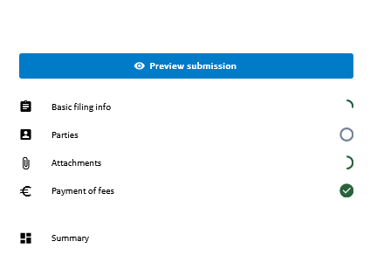

Figure 26 - Side bar of the ‘EP validation online filing’ page

Table 13 - Minimum required fields in each step of the 'EP validation online filing' page

|  |  |
| --- | --- |
| Minimum required fields in each step | |
| Basic filing info | Grant date, filing date, application number, publication number, language of grant (English, German or French) |
| Parties | At least one confirmed applicant |
| Attachments | An attachment of type of claims |
| Payments of fees | Select at least a payment intention |

The functionalities of the ‘EP validation online filing’ page are similar to the ‘Patent online filing’ page in National (see above).

By clicking Save & Close, the user is directed to the page where all EP validation submission can be managed (see below).

* + 1. EP validation submissions: Create subsequent action

By clicking in ‘Create subsequent action’, a pop-up window will appear to start a new subsequent action, as it did in the case for National patent submissions.

The process flow for a new subsequent action for EP validation submissions is the same as for National patent submissions (see above for more information).

While drafting the submission of each Subsequent Action, the user will be able to upload an attachment (see table below) considering the type of request.

Table 14 - Type of attachment for each respective request type in subsequent actions of EP validation submissions

|  |  |  |
| --- | --- | --- |
| **Category of the request** | **Request type** | **Type of attachment** |
| Document translations | Document translations | Claims |
| Abstract |
| Description |
| Drawings |
| Accompanying letter translation | Claims |
| Abstract |
| Description |
| Drawings |
| Appeal | Appeal procedure | Accompanying letter appeal |
| Notice of appeal |
| Withdrawal request |
| Additional documents appeal |
| Renunciation of appeal |
| Request restoration | Request restoration | Withdrawal request |
| Accompanying letter request restoration |
| Additional documents request restoration |
| Request restoration with payment | Accompanying letter request restoration |
| Additional documents request restoration |
| Request restoration |
| Hearing | Hearing | Request postponement hearing |
| Post after hearing |
| Cancellation Hearing |
| Additional documents hearing |
| Sequence list (ST.26 XML) | Sequence list WIPO ST.26 XML format (XML) | Sequence list WIPO ST.26 format XML |
| Sequence list (ST.26 ZIP) | Sequence list WIPO ST.26 ZIP format (ZIP) | Sequence list WIPO ST.26 format ZIP |
| Other | Other documents | Other documents |
| Change of address |
| Accompanying letter EPO-form |
| EPO-form |
| Request for advice | Request for advice | Withdrawal request |
| Reaction patent holder |
| Additional documents advice |
| Accompanying letter additional documents advice |
| Letter patent holder |
| Request for advice with payment | Additional documents advice |
| Advice request |
| Accompanying letter additional documents advice |

## My submissions

Once a specific submission process is selected (clicked on) an overview list of all submissions will be displayed with the status for the appropriate request, depending on the category. The possible status for any request can be found in the table below:

Table 15 - Status of the Submission

|  |  |
| --- | --- |
| Draft | A collection of data and documents pertaining to a particular eFiling service. It can consist of requests, responses, ad-hoc filing of documents, etc. |
| Ready to sign | Status of the submission in which the submission drafter has provided all necessary information to set the submission to the next status, in order for the submission signer to add a signature to the submission. |
| Signing failed | Please contact your National office for assistance. |
| Ready to pay | Status of the submission in which the submission drafter has provided all necessary information to set the submission to the next status, in order for the submission to be paid. |
| Ready to send | Status of the submission in which the submission signer has added the signature to the submission and is ready for the submission sender to send the patent request to the filing office. |
| Processing | A generated submission package for a patent request that is sent to the national patent office. |
| Packaging failed | Please contact your National office for assistance. |
| Sent | Status of the submission in which the submission sender has sent the submission to the filing office. |
| Sending failed | The submission could not be sent. Try resending the submission or contact your National Office for assistance. |

Any request can be selected to continue to be worked on it, or just to see more details depending on the status. These statuses can also be used to filter the list.

If the minimum required fields have been completed, a green arrow symbol will appear next to the Status. If the minimum required fields have not been completed, no arrow will appear.

**Submissions workflow of Online Filing**

While there are differences in the information required and processed with each submission type, the submissions workflow has a set of standard statuses and follows a generic process as seen bellow:



Figure 27 - Submissions workflow

* + 1. National patent submissions

In this page, you can create and manage submissions of national patent applications. You can search for the submissions that you want to send, from the list with all the submissions. Use the Filter button to make a faster search.

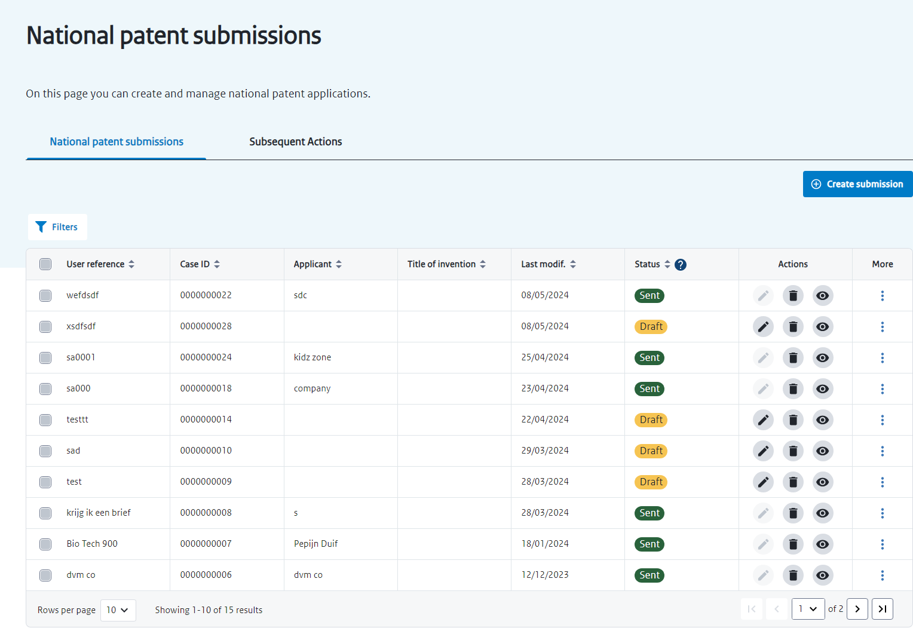

Figure 28 – ‘National patent submissions’ page

Table 16 - 'National patent submissions' page functionalities

|  |  |
| --- | --- |
| Create submission | It will direct you to the Patent online filing page where you can file a new national patent application. |
| Filters | You can filter the submissions by   * User reference * Case ID * Applicant * Title of invention * Last modification   and/or   * Status   By clicking ‘enter’ the filter will be assigned. You can click in Clear filters if you wish to delete all filters applied or you can click on the ‘x’ next to each filter to delete it. |
| ‘Select all’ square  (next to ‘Name’) | Selects all user references from the table.  The following options will appear for the selection:   * Delete * Change status * Move to another organization   When transferring submissions to other Organizations, all the data related to a specific submission will stop being visible to this organization. You can only transfer submissions to Organizations where you are a member. |
| ‘Select line’ square | Selects the respective line corresponding to a user.  You can select more than one user reference this way.  The following options will appear for the selection:   * Delete * Change status * Move to another organization   When transferring submissions to other Organizations, all the data related to a specific submission will stop being visible to this organization. You can only transfer submissions to Organizations where you are a member. |
| Fields | Each line represent a submission |
| Action ‘Edit’ | You can edit the submission draft in the ‘Patent online filing’ |
| Action ‘Delete’ | A pop-up window will appear to delete the submission selected. |
| Action ‘View’ | If Status is Draft, you can ‘Preview’ the submission or ‘View Summary’ of the submission.  If Status is Sent, you can view or download the submission receipt and the package. You can send an e-mail confirmation. |
| More | By clicking in the three dots, further actions are available dependent on the status and type of submission:   * Move to another organization * Create subsequent action * Send confirmation of reception via e-mail * Retry sending * Back to ready to sign |
| Results shown | You can filter the number of rows of individual users shown by page (10, 15, 20, 25, 50 or 100 rows). You can click in the arrows to go to the next page of results. |

#### 3.4.1.1 Sign submission

After verifying the content of the submission that is being previewed, select the Sign submission button to continue with the process.

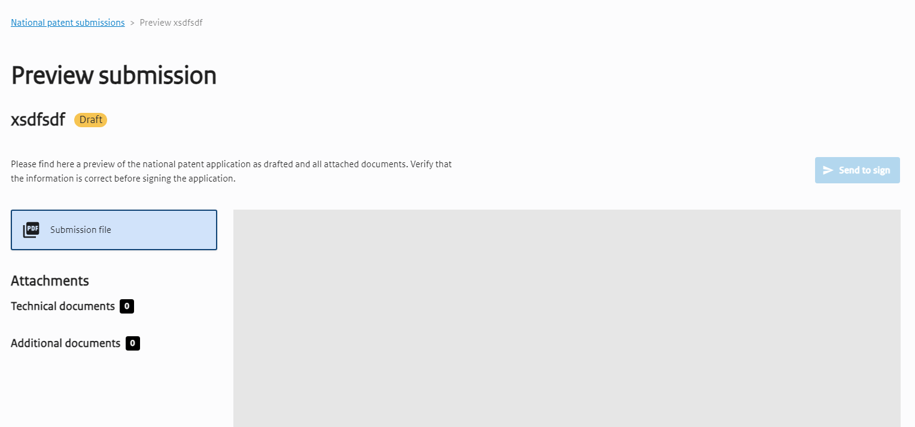

Figure 29 – ‘Preview submission’ page

A new window to Select the signer will appear. You need to select the party signing the submission. It is possible to select an existing signer or add a new one.

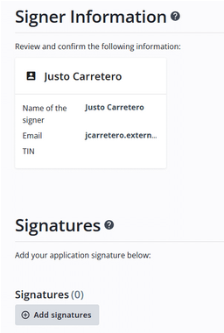

Figure 30 – ‘Add signature’ functionality

Click on Add signature and select the confirm signatures button to finish the process.

Select Send to package button to finish the process. A pop-up window will appear showing that the submission is being processed. Accept it and the signing process will be finished.

* + 1. National patent submissions: Subsequent Action

In this page, you can create and manage subsequent actions of national patent applications.

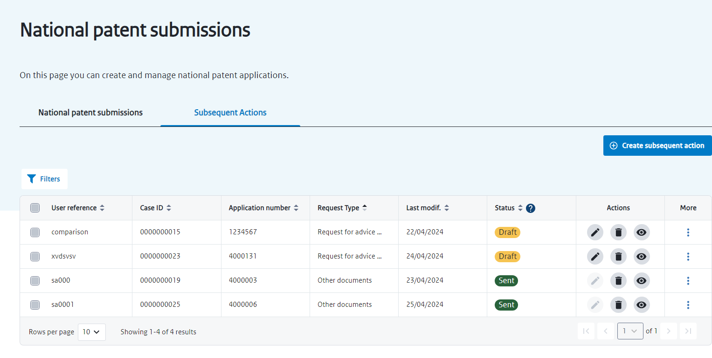

Figure 31 – ‘Subsequent Actions’ of national patent submissions page

Table 17 - Subsequent actions page functionalities (National patent submissions)

|  |  |
| --- | --- |
| Create subsequent action | A pop-up to create a new subsequent action will appear. |
| Filters | You can filter the subsequent actions by   * User reference * Case ID * Application number * Request type * Last modification   and/or   * Status   By clicking ‘enter’ the filter will be assigned. You can click in Clear filters if you wish to delete all filters applied or you can click on the ‘x’ next to each filter to delete it. |
| ‘Select all’ square  (next to ‘Name’) | Selects all user references from the table.  The following options will appear for the selection:   * Delete * Change status * Move to another organization   When transferring subsequent actions to other Organisations, all the data related to a specific submission will stop being visible to this organization. You can only transfer submissions to Organizations where you are a member. |
| ‘Select line’ square | Selects the respective line corresponding to a user.  You can select more than one user reference this way.  The following options will appear for the selection:   * Delete * Change status * Move to another organization   When transferring subsequent actions to other Organizations, all the data related to a specific action will stop being visible to this organization. You can only transfer actions to Organizations where you are a member. |
| Fields | Each line represent a subsequent action |
| Action ‘Edit’ | You can edit the respective subsequent action |
| Action ‘Delete’ | A pop-up window will appear to delete the submission selected. |
| Action ‘View’ | If Status is Draft, you can ‘Preview’ the submission or ‘View Summary’ of the respective submission.  If Status is Sent, you can view or download the submission receipt and the package. You can send an e-mail confirmation. |
| More | By clicking in the three dots, further actions are available dependent on the status and type of submission:   * Move to another organization * Send confirmation of reception via e-mail |
| Results shown | You can filter the number of rows of individual users shown by page (10, 15, 20, 25, 50 or 100 rows). You can click in the arrows to go to the next page of results. |

* + 1. EP validation submissions

In this page, you can create and manage EP validation submissions. The process flow is the same as for national patent submissions (see above for more information), with the additional filter of the publication number.

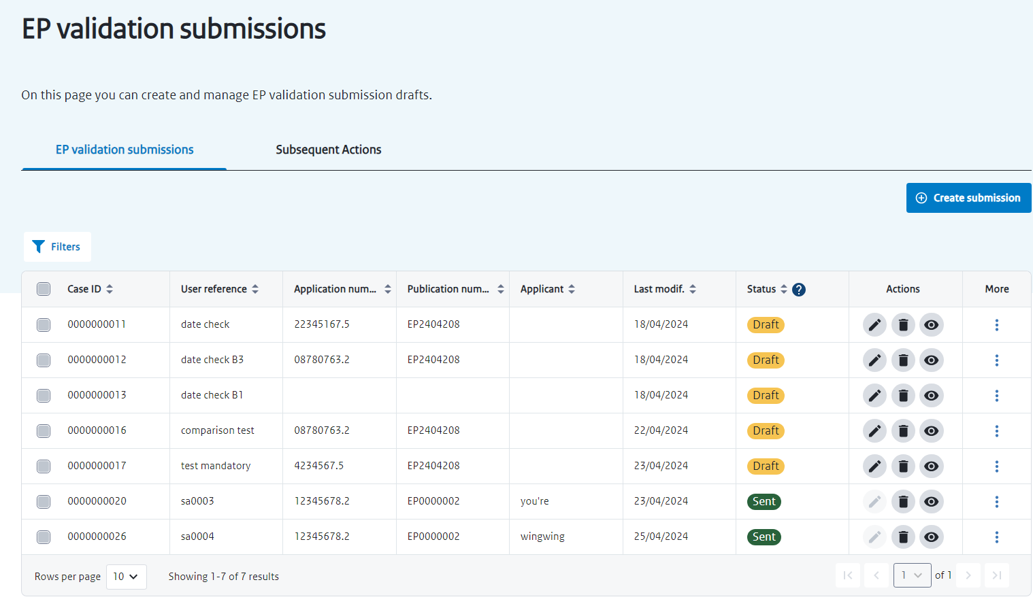

Figure 32 – ‘EP validation submissions’ page

* + 1. EP validation submissions: Subsequent Action

In this page, you can create and manage subsequent actions of EP validation submissions. The process flow is the same as for subsequent actions of national patent submissions (see above for more information), with the additional filter of the publication number.

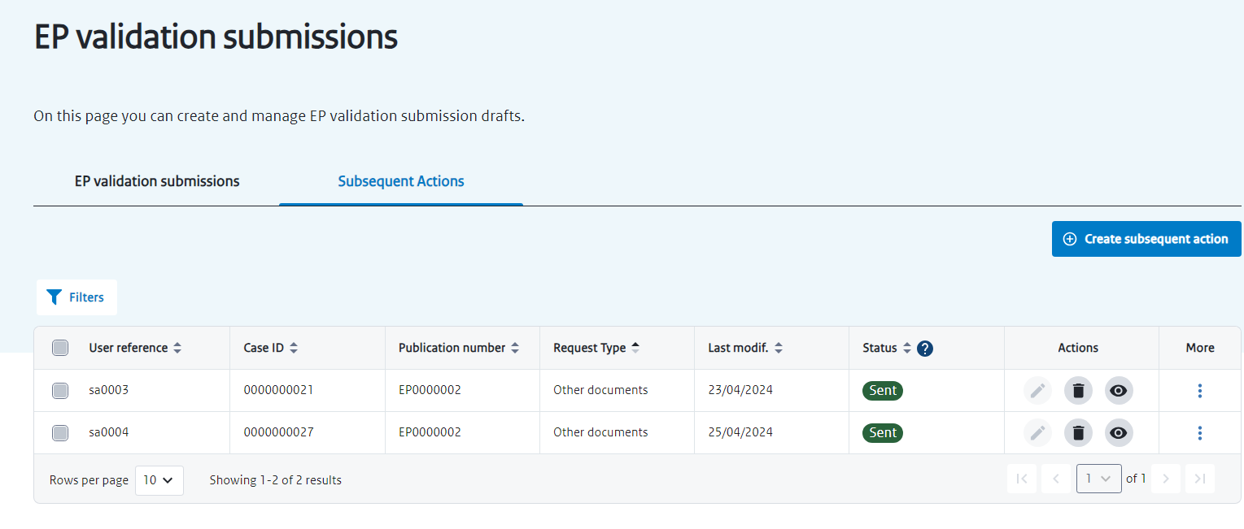

Figure 33 - Subsequent actions of EP validation submissions